Otowi to CPS

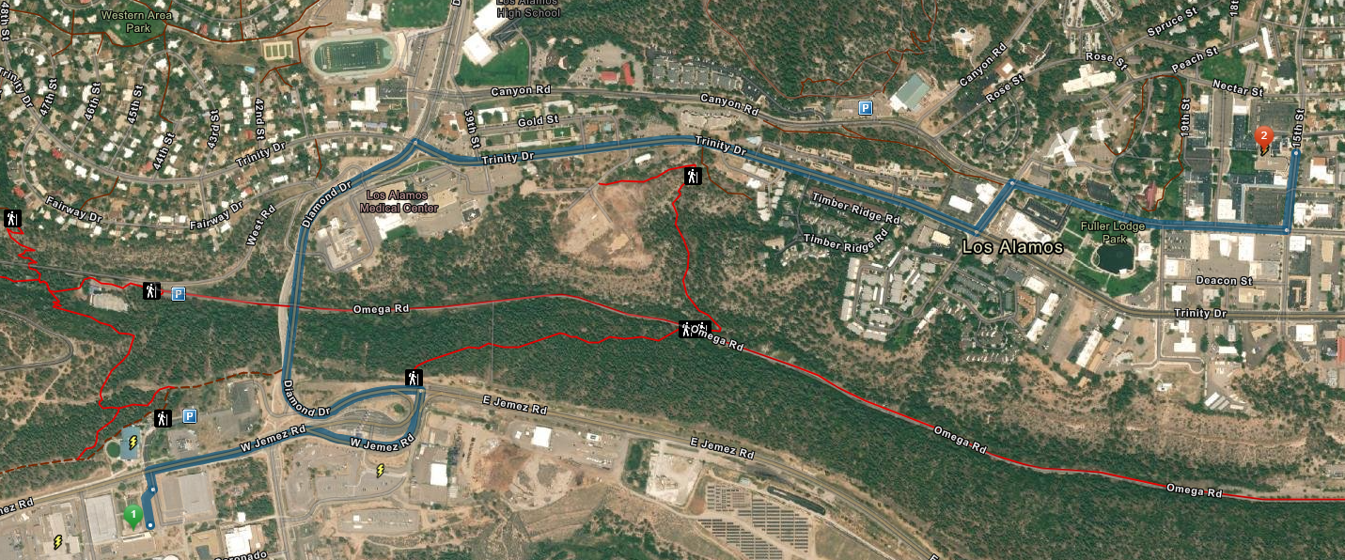

2.3miles
1 | 1. Start at Otowi Building  9:42 PM GMT+0000
2. Go north toward CASA GRANDE
0.05 mi
3. Turn left on CASA GRANDE then turn right on JEMEZ
0.43 mi
4. Turn left on DIAMOND
0.58 mi
5. Turn right on TRINITY
0.74 mi
6. Turn left on OPPENHEIMER
0.08 mi
7. Turn right on CENTRAL
0.36 mi
8. Turn left on 15TH
0.10 mi
2 | 9. Finish at Central Park Square on the left
CPS Badge Office

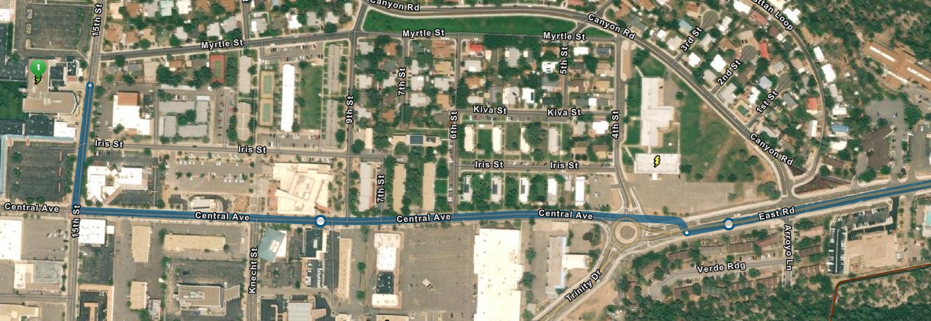

1 | 1. Start at 00-1355  10:08 PM GMT+0000
2. Go west on EAST toward SOMBRILLO
0.10 mi
3. Turn right on CANYON
0.23 mi
4. Turn left on 4TH then turn right on MYRTLE
0.42 mi
5. Turn left on 15TH
0.02 mi
2 | 6. Finish at Central Park Square on the right
Location: TA-00-787-1001 Central Park Badge Office. 125 15th Street. Park on the North side of the building in the parking lot at the Nectar and 15th st intersection. If you do not have an active badge you will need to enter through the doors on the West side (follow the signs). The badge reader is deactivated at the West entrance 7:00-3:30 Monday through Friday.

